Could cookbooks be the latest victim of millennials, and increasingly, Gen-Z’ers? Publication trends seem to suggest the era of printed recipes is coming to an end.

However, the cookbook has had a surprising run peaking in 2014, well after the emergence of the internet and the rise in popularity of food blogs, particularly over the last decade.

Until this point, the cookbook saw a steady rise over the 20th century, first making an appearance in the late 1800s and seeing a meteoric rise at the onset of post-World War II life.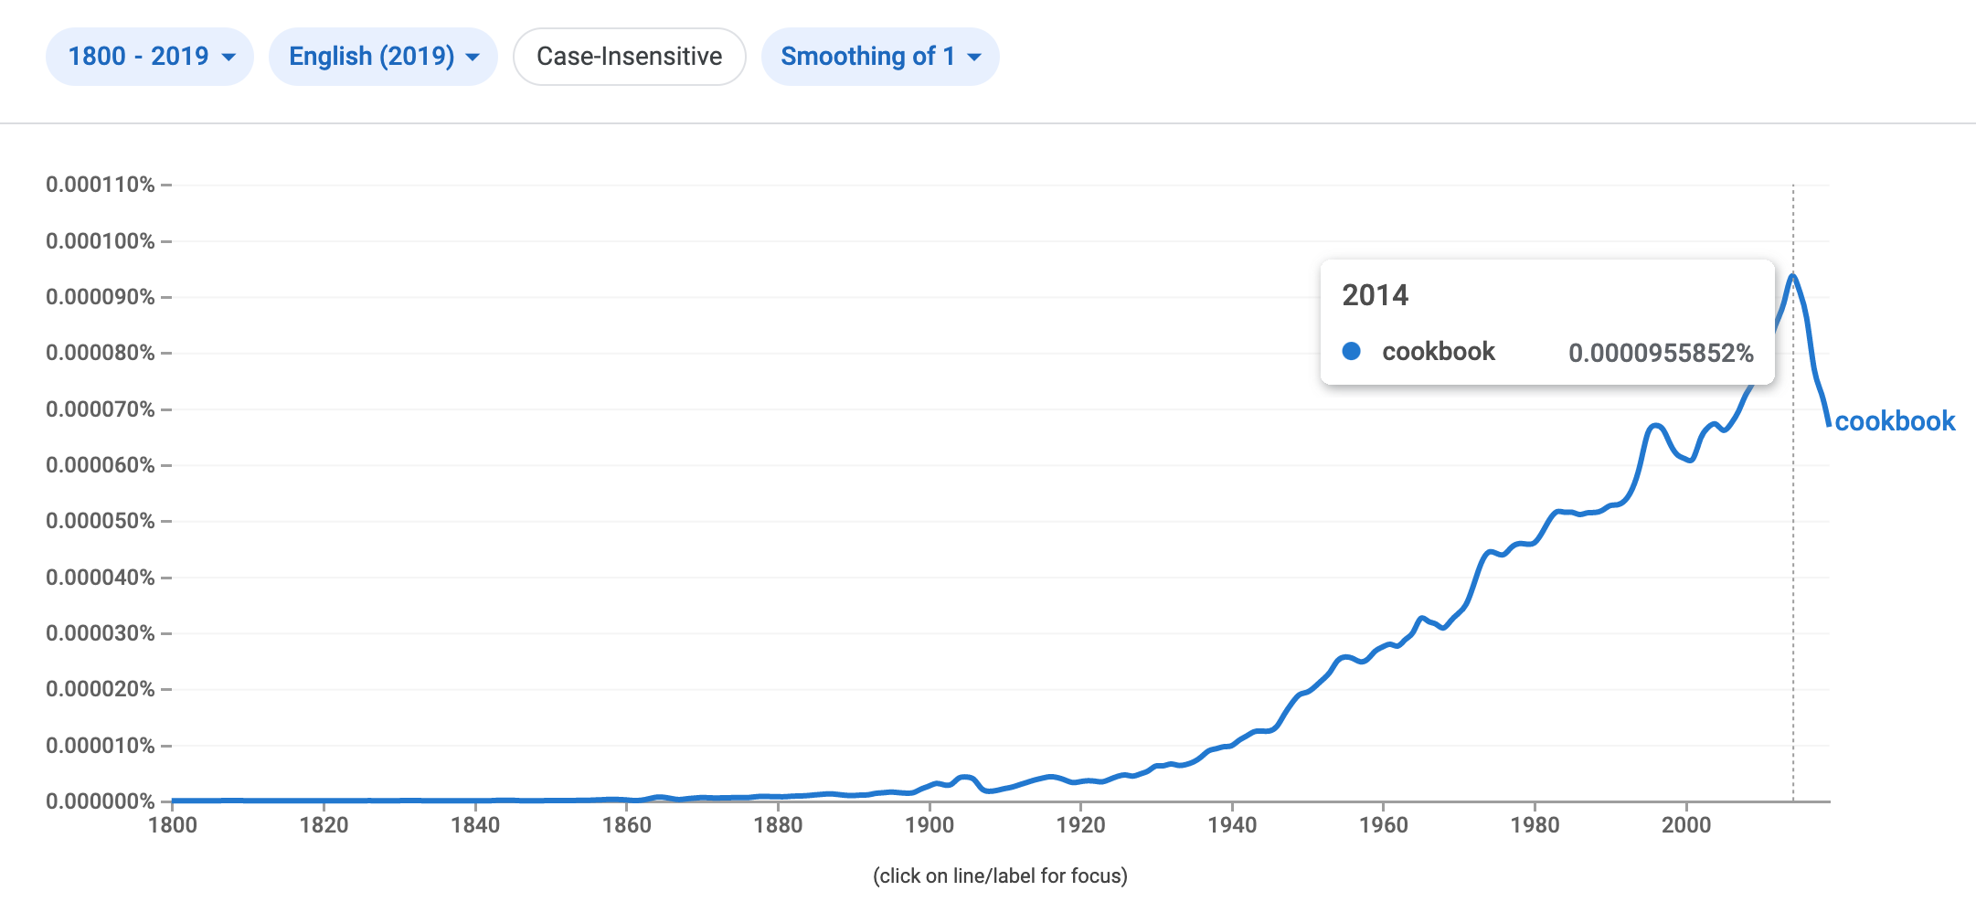

Interestingly, the portmanteau of “cookbook” appears to be the invention of the 1920s, muddying the ability to track the ebbs and flow of the genre’s popularity. Prior to this time, these books were almost exclusively referred to in two words, as “cook books”.

The lifeline of the “cook book”, despite the predecessor of the term “cookbook", shows a much bleaker spark and fade. Its peak occurrence at just under 0.0000200% was reached in the 1940s. By comparison, “cookbook” reached this point as well in the 1940s, but continued to rise up to 0.0000955% to 2014. 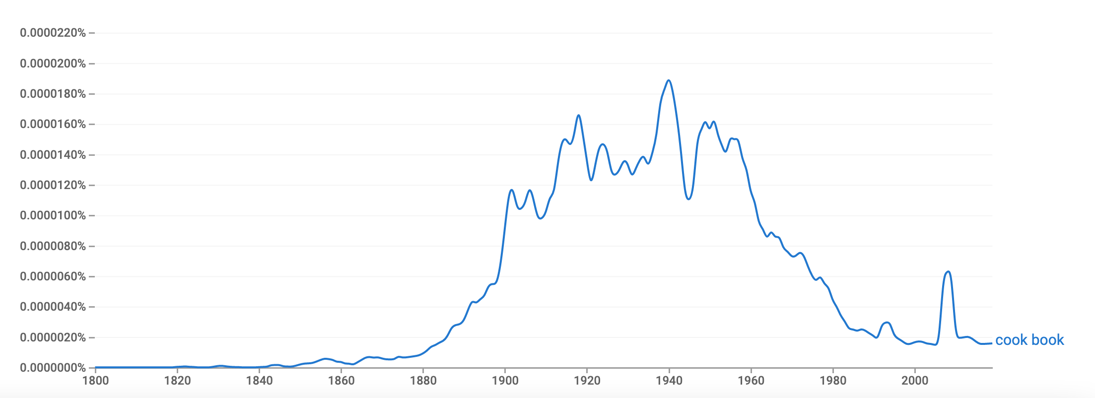

Regardless of terminology, it seems that the publication of cookbooks (and cook books) has passed its prime. With recipes so readily available online and a dire housing market limiting the amount of shelf space one can devote to cookbooks, it seems that the cookbook may soon be a relic of the past.